**Regression Analysis Report: Annual Motor Sales**

MIS 540 Introduction to Business Intelligence

Colorado State University-Global Campus

Dr.  Orenthio Goodwin

March 5, 2022

Regression Analysis Report: Annual Motor Sales

In this project I will use the dataset motor_sales.csv. The dataset includes six manufacturing cities – Kansas City, Chicago, Houston, Oklahoma City, Omaha, Little Rock – and monthly sales for each site. I used proc reg for each factory output to generate regression statistics and models. Next, I will forecast engine sales for the next three months. SAS has a modeling and forecasting option under tasks. I chose the Arimax 311 modeling format. I learned this format from an SAS video tutorial.

Business Question

1. Engine sales will increase in each factory for the next quarter.
2. Factories will maintain consistent sales each month.

Alternate and Null Hypotheses

Null Hypothesis (Ho)

Ho: Engine sales will increase in each factory for the next quarter.

Alternative Hypothesis (Ha)

Ha: Engine sales will decrease in each factory for the next quarter.

Null Hypothesis (Ho)

Ho: Factories will maintain consistent sales each month.

Alternative Hypothesis (Ha)

Ha: Factories will not maintain consistent sales each month.

Tests

The first test used was reg proc to test each factory sales by month. It is import to check the diagnostic plots to assess the quality of fit for the model. By testing monthly sales data for each factory. SAS provides the plots= function to generate diagnostic plots. The plots will help evaluate the fit of the model, to determine whether the data satisfies expectations about the dataset, and identify outliers and high-leverage points.

Figure 1. Fit Diagnostics

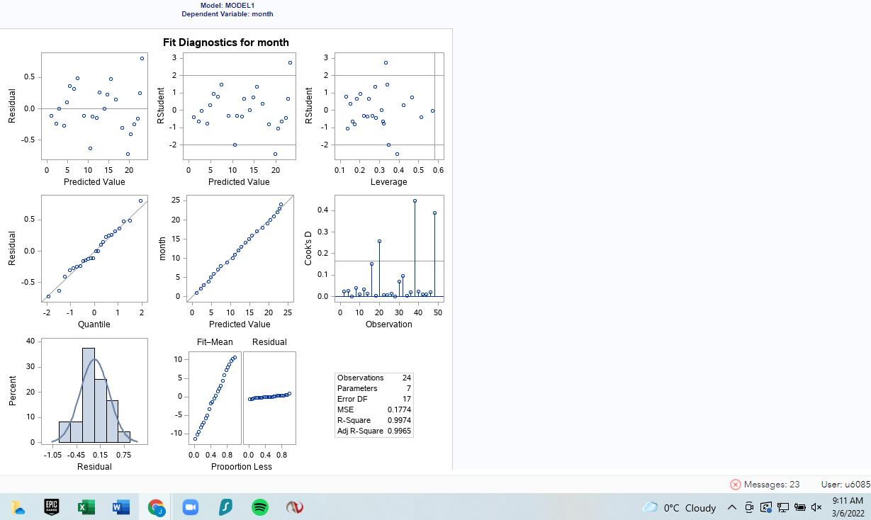

Note. SAS screenshot.

Looking at the center panel – predicted model by month – all the markers are closely aligned with the vertical line. The plot lacks any observations far from the predicted response. This indicates the model fits the data. The residual – predicted value plot one outlier above 0.5 and two outliers below 0.5. The remaining nineteen observations fall well within the expected value. The RStudent – predicted value chart resembles the residual – predicted value plot with value above +2, one borderline value and one value below -2. The RStudent – leverage and Residual -quantile plots are consistent with the previous plots discussed. Overall, the model is significant for fit.

Engines Sales Forecast

This section will examine the three-month engine sales forecasts for each factory. The dates for each forecast should be considered monthly. I was unable to change from days to months in SAS.

Figure 2. Kansas Three Month Sales Forecast

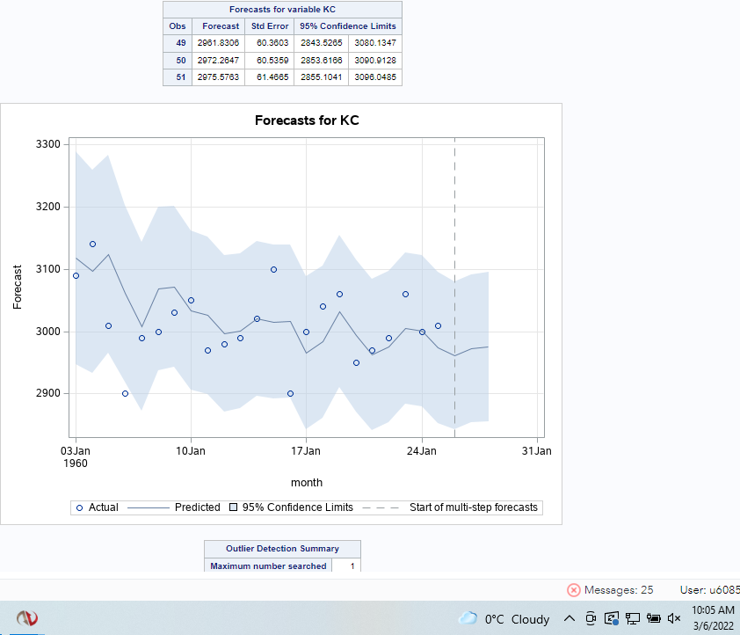

Note. SAS screenshot.

**Kansas City**

Kansas City is the most difficult to forecast consistently for the next three months. Month one and two have the largest discrepancy in forecast. Month three is slightly more predictable. There is one outlier in month one. The predicted sales line is inconsistent while the 95% confidence limits are wide.

Figure 3. Chicago Three Month Sales Forecast

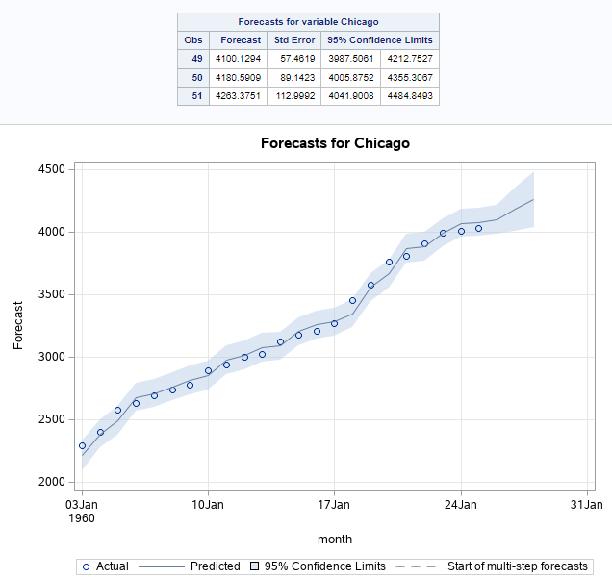

Note. SAS screenshot

**Chicago**

Chicago sees a month over month increase in the next three months. Chicago does not have any outliers. This is significant for consistent production planning. The standard error increases month over month but not as significantly as other cities. The 95% confidence limit remains close to the predicted sales line.

Figure 4. Houston Three Month Sales Forecast

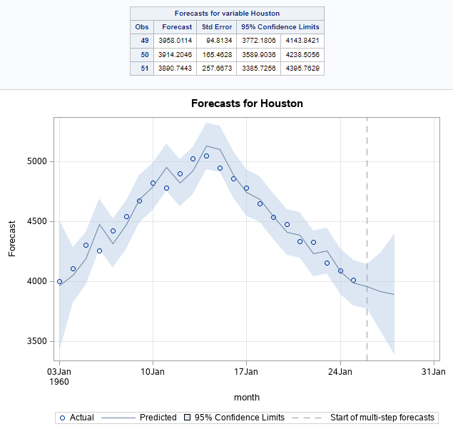

Note. SAS screenshot

**Houston**

Houston is significant because of declining sales from month two to month three. Production will need to be reduced in month three to account for decreased sales. The caveat to the decline is the large standard error between months one and two compared to month three. Though production may be reduced it would be wise to maintain flexibility to increase production quickly if engine sales see an increase. The 95% confidence limit shows consistency around the predicted sales line in all three months.

Figure 5. Oklahoma City Three Month Sales Forecast

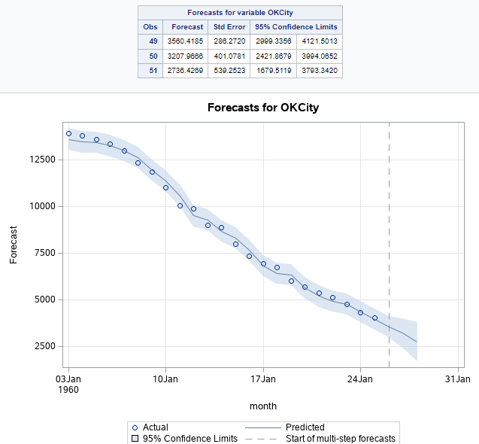

Note. SAS screenshot

**Oklahoma City**

Oklahoma City sees a significant decline in engine sales in the next three months. In month three sales forecast is low as 1679 engines. This point may need to be further researched for consistency for the upcoming quarter. If the decline is consistent in this quarter year over year, this month may be considered for significant maintenance or possible factory upgrades. Production can be shifted to other factories. The standard error increase month over month. The 95% confidence interval is narrow with the predicted sales line.

Figure 6. Omaha Three Month Sales Forecast

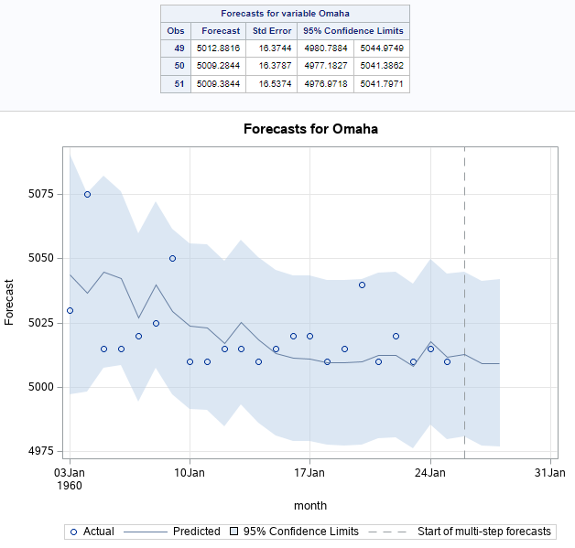

Note. SAS screenshot

**Omaha**

Omaha is the highest selling factory for the company. There is an outlier and significant increase actual point in month one. The standard error for each month is consistent over the three months. The 95% confidence limit is significant for the three months. Sales forecast trend around the predicted line with significant actuals predicted in months one and three.

Figure 6. Little Rock 3 Month Sales Forecast

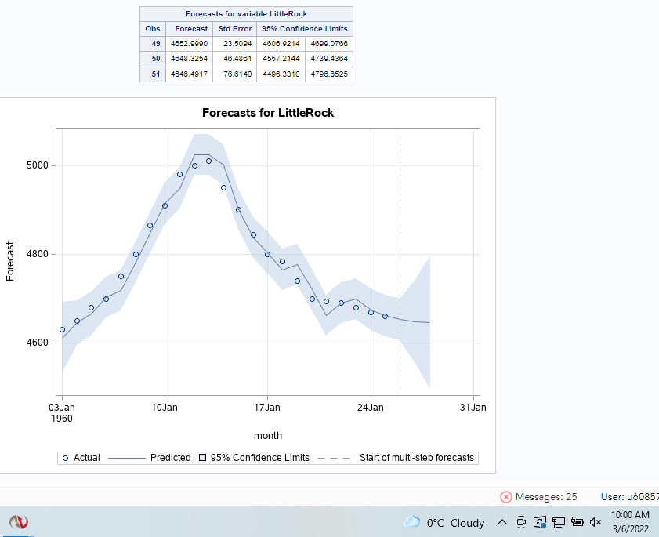

Note. SAS screenshot.

**Little Rock**

Little Rock has a sales increase from month one to month two. Month two to month three sees an equal decline in sales. The actual sales and predicted sales show little variability. The 95% confidence limit is close to the predicted sales line. Similar to Houston, Further research needs to done to assess the frequency and timing of the decline in sales.

Conclusion

Sales forecast are an important aspect for production facilities. Producing too many engines will cause increased costs for storage and maintenance of the engines while in stock. Under production will lead to missed sales opportunities. Another consideration is maintenance. Manufacturing facilities require maintenance - emergency and scheduled – throughout the year. Knowing expected sales allows maintenance to be performed during months with low-production. Emergency situations can be minimized by understanding production abilities in other factories while the emergency is being resolved.

References

SAS Videos (n.d.). Time Series Modeling and Forecasting Using SAS Studio. Retrieved from https://video.sas.com/detail/videos/forecasting/video/4414522299001/time-series- overview-using-sas-studio?autoStart=true

Woodward, A.C.E.W. A. (2015). SAS Essentials: A Guide to Mastering SAS (2nd Edition). Wiley Global Research (STMS). https://mbsdirect.vitalsource.com/books/9781119042198